Conference Organization
General Chair
Shing-Chi Cheung, The Hong Kong University of Science and Technology
Program Chairs
Alessandro Orso, Georgia Institute of Technology
Margaret-Anne Storey, University of Victoria
Workshop Chairs
Shigeru Chiba, The University of Tokyo
Frances Paulisch, Siemens AG
Visions and Challenges Chairs
Jian Lv, Nanjing University
Tao Xie, University of Illinois at Urbana-Champaign
Tutorial Track Chair
Jo Atlee, University of Waterloo
Doctoral Symposium Chairs
Abhik Roychoudhury, National University of Singapore
Xiangyu Zhang, Purdue University
Research Demos Chairs
Darko Marinov, University of Illinois at Urbana-Champaign
Minghui Zhou, Peking University
Industry Relation Chair
Wolfgang Emmerich, Zuhlke Engineering Ltd. and University College London
Student Volunteer Chairs
Christian Bird, Microsoft Research
Jacky Keung, City University of Hong Kong
Artifacts Evaluation Chairs
Antonio Carzaniga, University of Lugano
Prem Devanbu, University of California Davis
ACM Student Research Competition Chair
Dongmei Zhang, Microsoft Research
Local Arrangements Chair
Hareton Leung, The Hong Kong Polytechnic University
Registration Chair
Eric Bodden, Fraunhofer SIT
Publicity Chairs
Diego Garbervetsky (S. America), University of Buenos Aires; Reid Holmes (N. America), University of Waterloo; Sung Kim (Asia), Hong Kong University of Science and Technology; Martin Pinzger (Europe & Africa), University of Klagenfurt
Proceedings Chair
Sam Malek, George Mason University
Web and Social Media Chairs
Shauvik Roy Choudhary, Georgia Institute of Technology
Leif Singer, University of Victoria
FSE 2014
Treasurer
Y.T. Yu, City University of Hong Kong
Graphic Designer
T.H. Tse, The University of Hong Kong
Conference Secretary
Yepang Liu, The Hong Kong University of Science and Technology
22nd ACM SIGSOFT International Symposium on the
Foundations of
Software Engineering
November 16–21, 2014
Hong Kong
http://www.sigsoft.org/fse22/
Call for Participation
Registration is now open for FSE 2014. The ACM SIGSOFT International Symposium on the Foundations of Software Engineering (FSE) is an internationally renowned forum for researchers and practitioners from academia and industry to present and discuss the most recent innovations, trends, experiences, and challenges in software engineering. FSE is
well known for the high quality of its technical presentations.

To register, please visit the registration website:
http://www.sigsoft.org/fse22/registration

Early registration cutoff date is October 5, 2014. Online registrations will close by November 9, 2014. Please follow http://www.facebook.com/fse14 on Facebook and @FSEconf on Twitter to receive our latest news!

Program Highlights:
- 4 inspiring keynote/invited talks
- 61 technical paper presentations
- 7 visions and challenges presentations
- 8 enrichment tutorials
- 7 workshops
- 6 student research competition presentations
- 15 tool demonstrations
- 10 doctoral symposium presentations
- Internetware 2014 (co-located event)
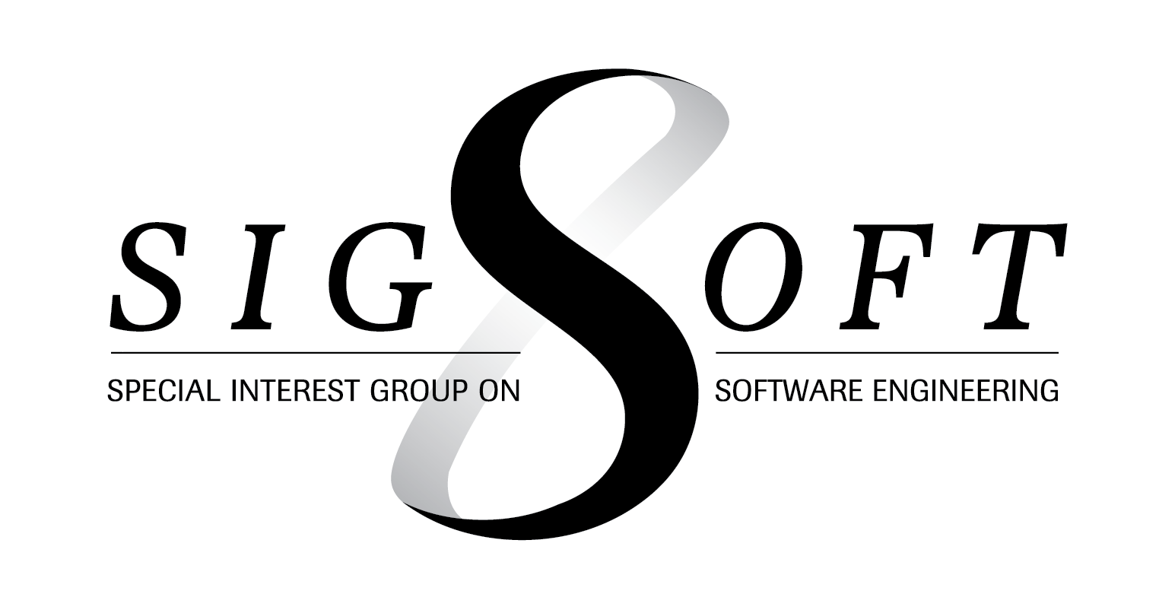
Sponsors:

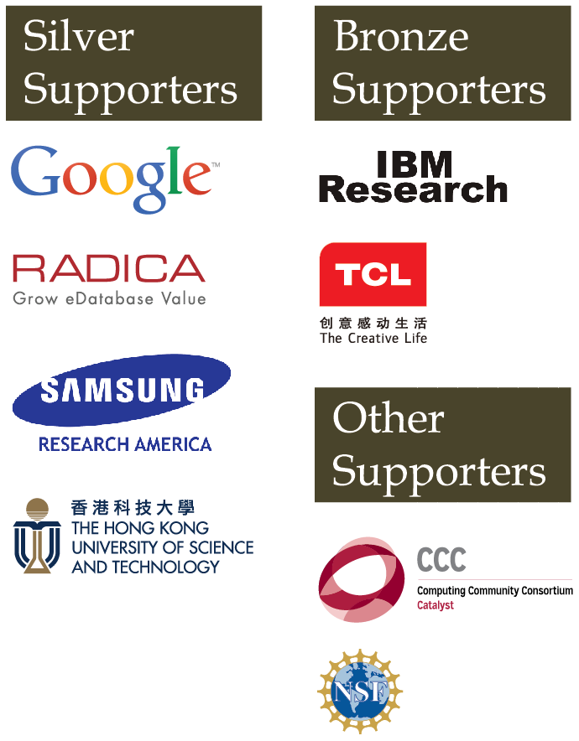
Supporters:

